**WEEK -5 ( 6428652 )**

**Account Microservice**

**Codes:**

**AccountController.java:**

package com.cognizant.account.controller;

import org.springframework.web.bind.annotation.GetMapping;

import org.springframework.web.bind.annotation.PathVariable;

import org.springframework.web.bind.annotation.RestController;

class Account {

private String accountType;

private String accountNumber;

private int balance;

private String status;

public Account(String accountType, String accountNumber, int balance, String status) {

this.accountType = accountType;

this.accountNumber = accountNumber;

this.balance = balance;

this.status = status;

}

public String getAccountType() {

return accountType;

}

public String getAccountNumber() {

return accountNumber;

}

public int getBalance() {

return balance;

}

public String getStatus() {

return status;

}}

@RestController

public class AccountController {

@GetMapping("/accounts/{number}")

public Account getAccountByNumber(@PathVariable String number) {

return new Account("Savings", number, 50000, "Active");

}

}

**Application.properties :**

server.port=8080

**Output:**

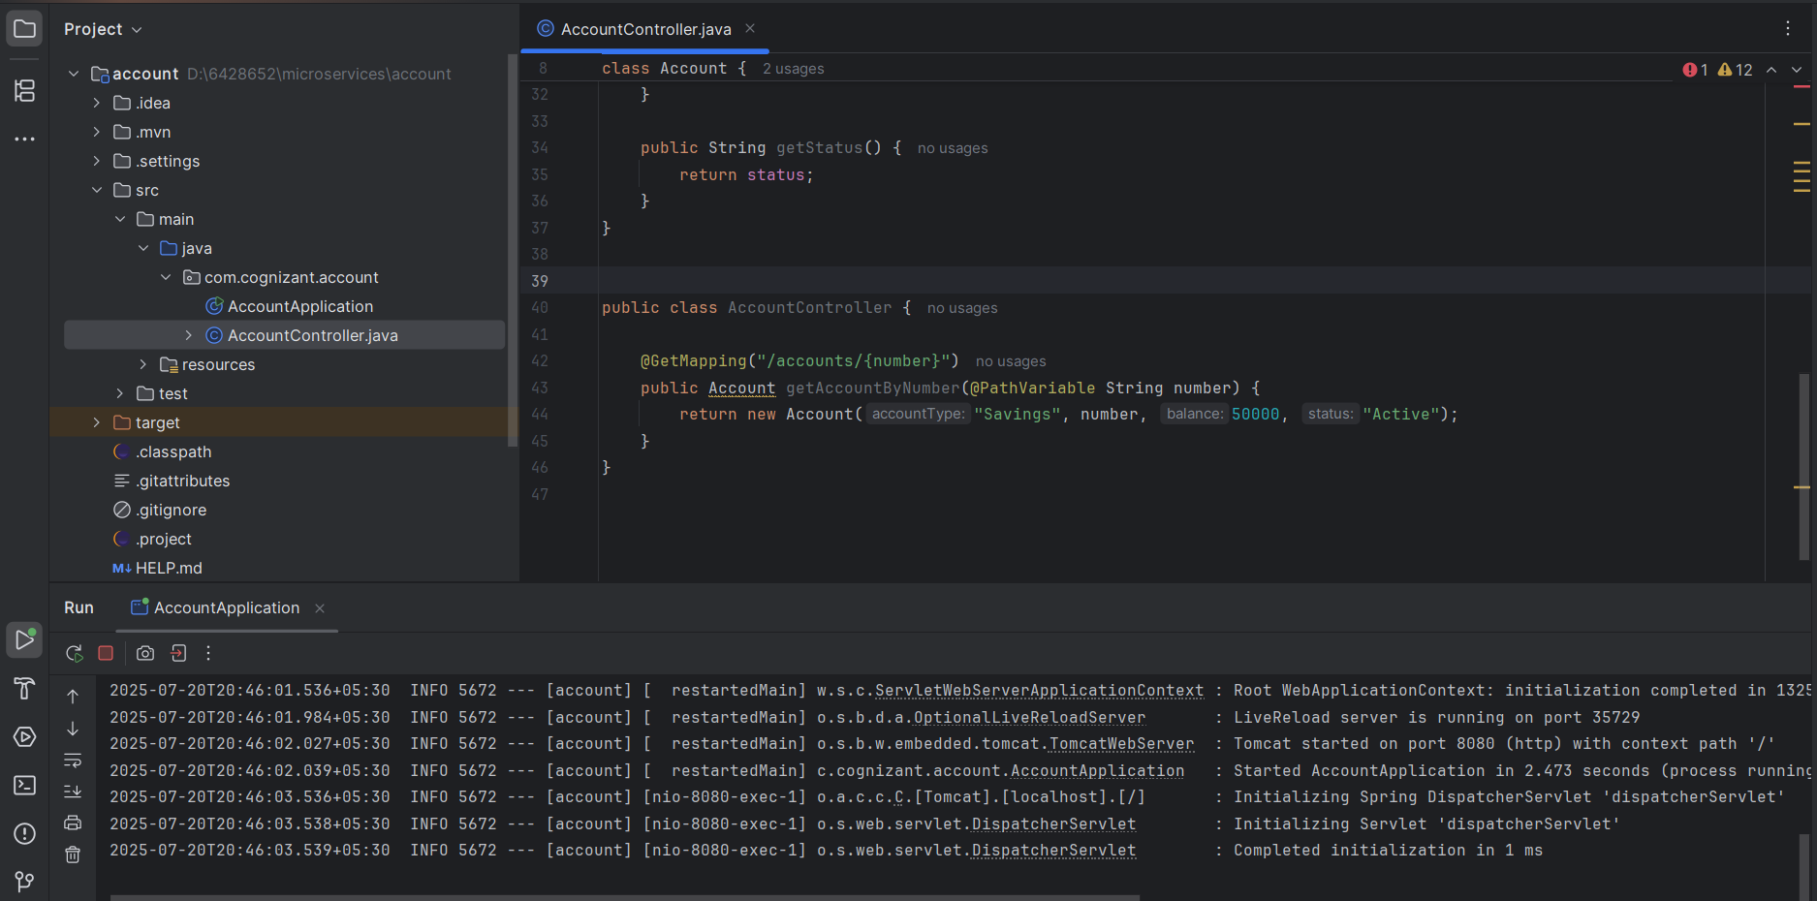

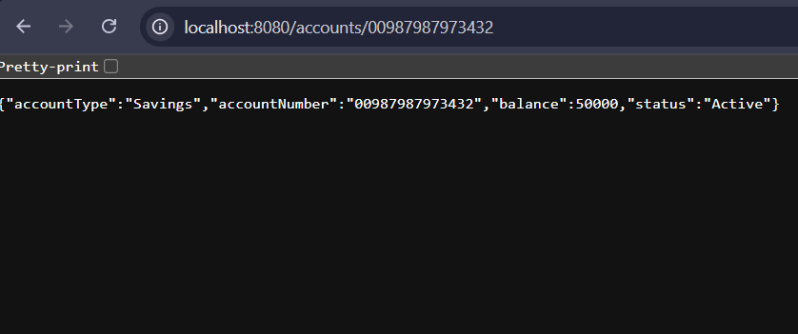

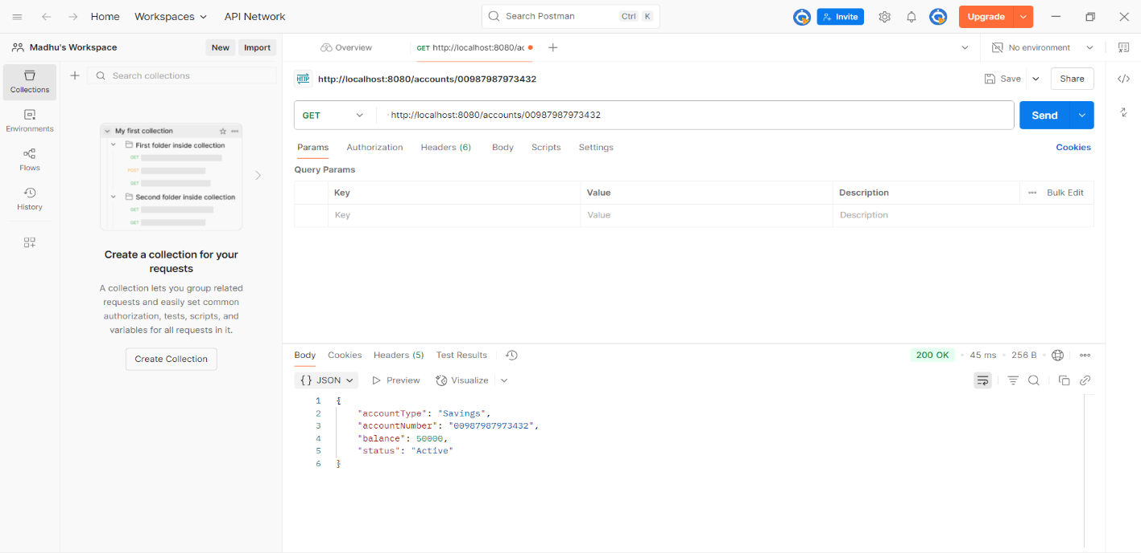

**Loan Microservice**

**LoanController.java**

package com.cognizant.loan.controller;

import org.springframework.web.bind.annotation.GetMapping;

import org.springframework.web.bind.annotation.PathVariable;

import org.springframework.web.bind.annotation.RestController;

class Loan {

private String number;

private String type;

private int loan;

private int emi;

private int tenure;

public Loan(String number, String type, int loan, int emi, int tenure) {

this.number = number;

this.type = type;

this.loan = loan;

this.emi = emi;

this.tenure = tenure;

}

public String getNumber() {

return number;}

public String getType() {

return type;

}

public int getLoan() {

return loan;

}

public int getEmi() {

return emi;

}

public int getTenure() {

return tenure;

}

}

@RestController

public class LoanController {

@GetMapping("/loans/{number}")

public Loan getLoanDetails(@PathVariable String number) {

return new Loan(number, "car", 400000, 3258, 18);

}

}

**application.properties**

server.port=8081

**Output:**

